44.28: a) 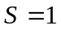 indicates the presence of one antiquark and no s quark. To have baryon number 0 there can be only one other quark, and to have net charge + e that quark must be a u, and the quark content is 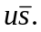 b) The particle has an antiquark, and for a baryon number of –1 the particle must consist of three antiquarks. For a net charge of –e, the quark content must be 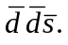 c) 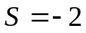 means that there are two s quarks, and for baryon number 1 there must be one more quark. For a charge of 0 the third quark must be a u quark and the quark content is uss.

